Assignment 15: Build a Topic-Specific Expert Chatbot

Step 1: Select a Topic:
I choose Educational Technology topic

Step 2: Generate my Dataset:
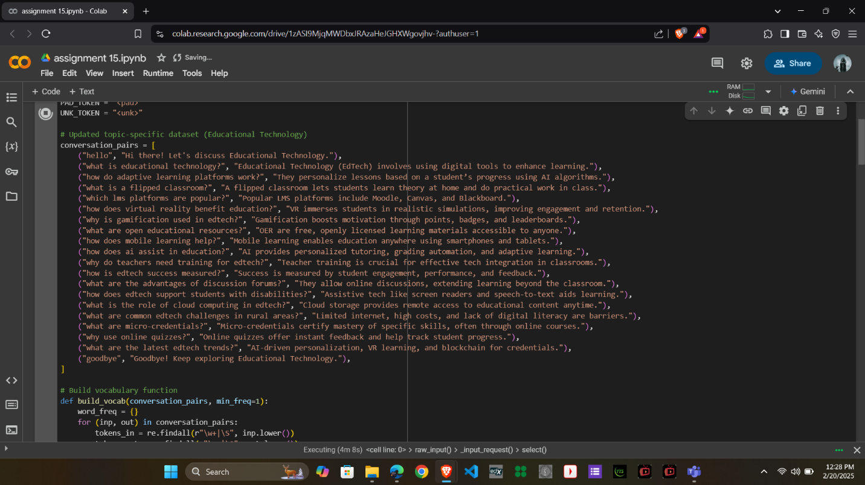

Step 3: Adjust the Code Parameters:
Max Length (max_len): 60
Training Epochs: 150
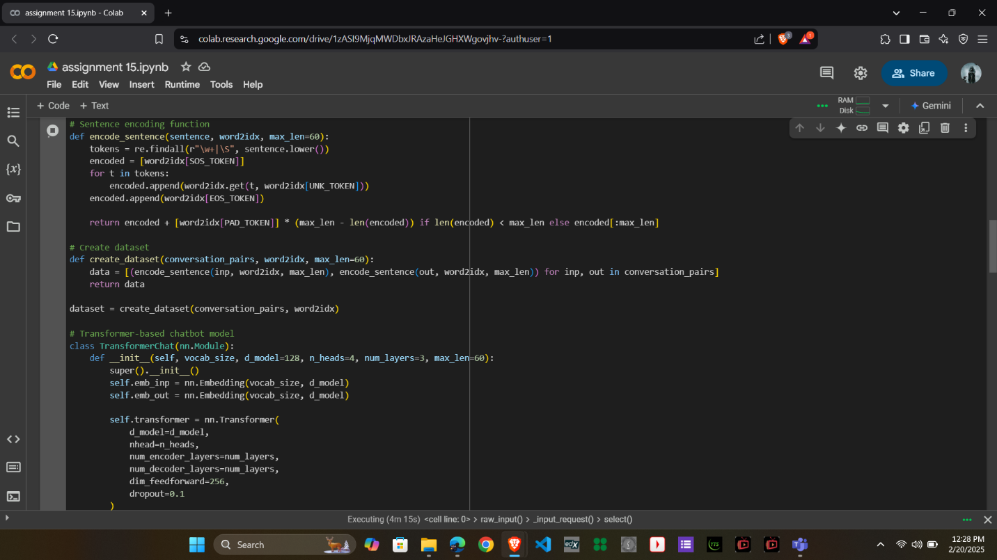
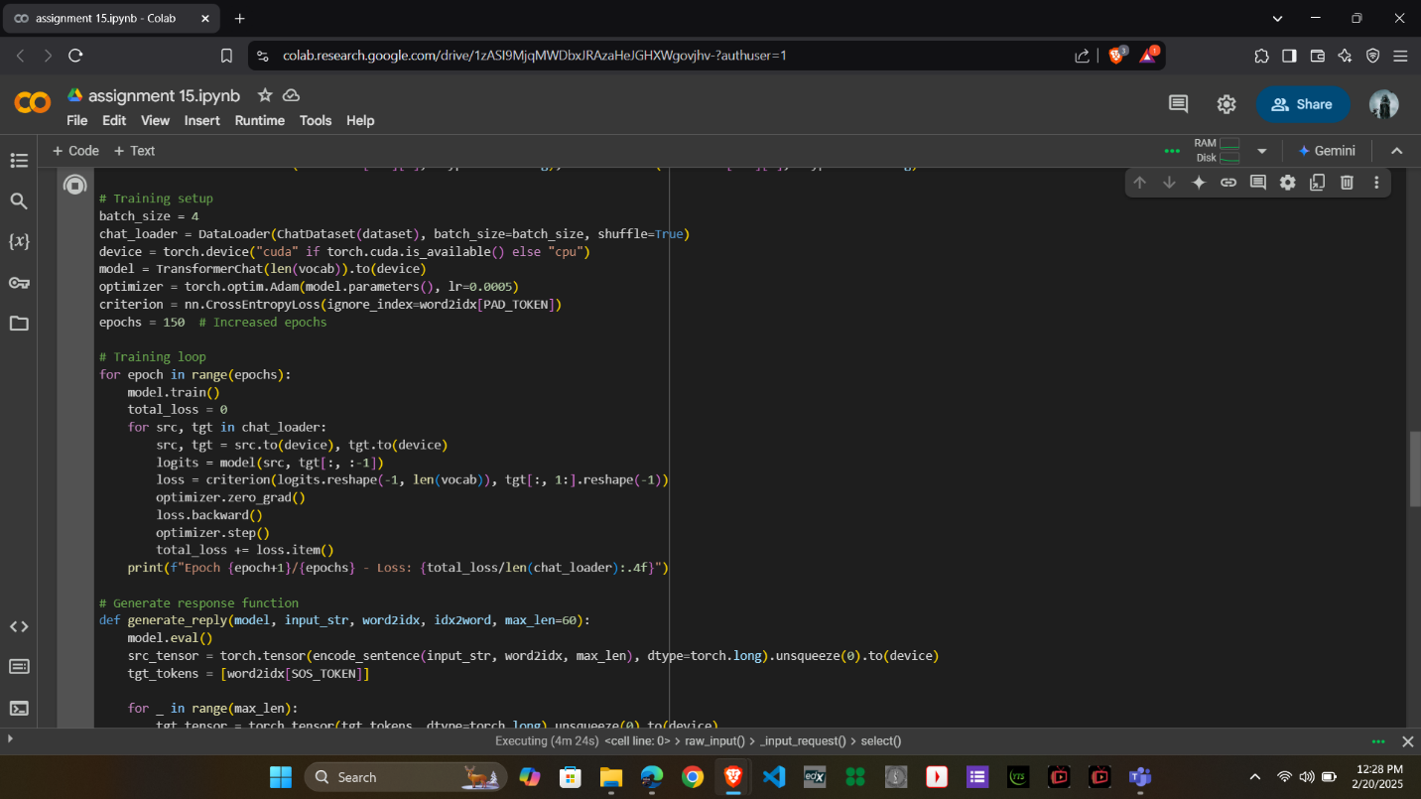

Step 4: Train my Chatbot:
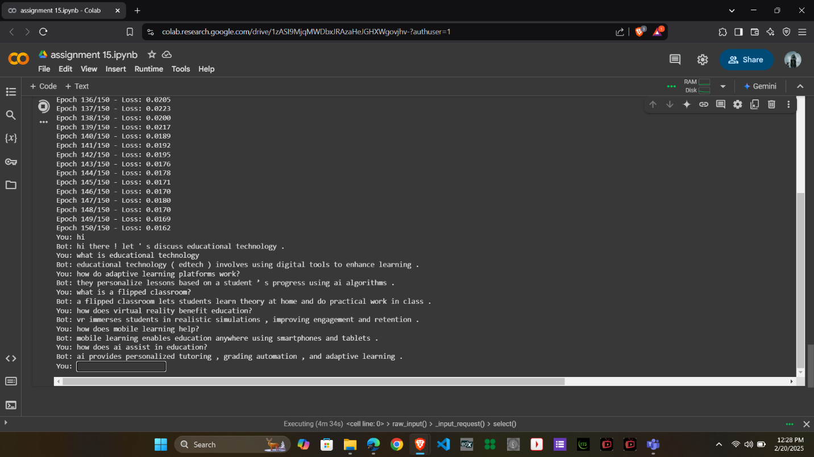
Step 5: Test and Evaluate:

Report:
- Parameter Adjustments
- Max Sequence Length (max_len)
  - Increased from 50 to 60 to handle longer educational answers without truncation.
- Training Epochs
  - Increased from 100 to 150 epochs to allow the model to learn more effectively from the dataset.
- Model Architecture Adjustments
  - Embedding Dimension (d_model) increased from 64 to 128 for better feature extraction.
  - Number of Transformer Layers (num_layers) increased from 2 to 3, improving learning depth.
  - Number of Attention Heads (n_heads) increased from 2 to 4 to allow the model to capture more complex relationships in text.
  - Feedforward Layer (dim_feedforward) increased from 128 to 256 for better representation learning.
- Learning Rate Adjustment
  - Decreased from 0.001 to 0.0005 to stabilize training and avoid overfitting.
2. Improved Training Process
- Batch size increased from 2 to 4 for better generalization.
- Cross-Entropy Loss (ignore_index=PAD_TOKEN) ensures that padding tokens do not impact training.

